**ASSIGNMENT 02**

OBJECT ORIENTED PROGRAMMING



GROUP MEMBERS:

|  |  |
| --- | --- |
| NAME | ENROLLMENT. NO |
| Saad Ahmad | 01-134222-130 |
| Syed Abdullah Shah | 01-134222-143 |
| Sohaib Ahmed | 01-134222-142 |

**DEPARTMENT OF COMPUTER SCIENCES**

**BAHRIA UNIVERSITY, ISLAMABAD CAMPUS**

***Question:*** Can you enhance this code by adding concept of Inheritance? If Yes, then which classes you will add and what functionalities you would like to add. (Write an Enhanced Complete code for this question). Consider writing all accessors and mutators along with other functions for all classes.

**Enhanced Code:**

//Syed Abdullah Shah

//Saad Ahmed

//Sohaib Ahmed

#include<iostream>

#include<string>

using namespace std;

class Date {

protected:

int day;

int month;

int year;

public:

//Default Value Constructor

Date(int tempDate=1, int tempMonth=1, int tempYear=1) : day(tempDate), month(tempMonth), year(tempYear) {}

//Setter Functions

void set_day(int day)

{

this->day = day;

}

void set_month(int month)

{

this->month = month;

}

void set_year(int year)

{

this->year = year;

}

//Getter Functions

int get_day() const

{

return day;

}

int get_month() const

{

return month;

}

int get_year() const

{

return year;

}

};

class Details {

protected:

string name;

int ID;

public:

//Default value constructor

Details(string tempName="", int tempID=1) :name(tempName), ID(tempID) {}

//Setter Functions

void set_name(string name)

{

this->name = name;

}

void set_id(int id)

{

ID = id;

}

//Getter Functions

string get_name() const

{

return name;

}

int get_id() const

{

return ID;

}

};

class Customer : public Details

{

private:

string email;

string address;

public:

//Default Value Constructor

Customer(int tempID=0, string tempName=" ", string tempAddress=" ", string tempEmail=" ") : Details(tempName, tempID)

{

set_email(tempEmail);

validateEmail();

set_address(tempAddress);

}

//Setter Functions

void set_email(string email)

{

this->email = email;

}

void set_address(string address)

{

this->address = address;

}

//Getter Functions

string get_email() const

{

return email;

}

string get_address() const

{

return address;

}

void validateEmail() { //Function to check if the email has @ and . in it

int i, j;

bool check;

do {

int length = email.length();

check = false;

for (int i = 0; i < length; i++)

{

if (email[i] == '@')

{

for (int j = 0; j < length; j++) {

if (email[j] == '.')

{

check = true;

break;

}

}

}

}

if (check == false)

{

cout << "Enter a valid email address with \"@\" and \".\" " << endl;

cin >> email;

}

} while (check != true);

}

};

class Item : public Details {

protected:

double itemPrice;

public:

Item(int tempID=1, string tempName=" ", double tempPrice=0) : Details(tempName, tempID) {

set_item_price(tempPrice);

}

//Setter Function

void set_item_price(double item_price)

{

itemPrice = item_price;

}

//Getter Function

double get_item_price() const

{

return itemPrice;

}

};

class Order : public Item {

private:

int orderID;

Customer customer;

Date orderDate;

double orderTotal;

int quantity;

public:

//Empty Constructor

Order();

//Parameterized Constructor

Order(int tempID, Customer tempCustomer, Date tempOrderDate, Item tempItem)

: orderID(tempID),

customer(tempCustomer),

orderDate(tempOrderDate),

Item(tempItem)

{

}

//Member Functions

void addOrderDetail(Item tempItem, int tempQuantity)

{

name = tempItem.get_name();

itemPrice = tempItem.get_item_price();

set_quantity(tempQuantity);

}

void calculateTotal()

{

set_order_total(get_item_price() * quantity);

}

void displayOrderDetails() {

cout << " Order Details" << endl << endl;

cout << " ------------------------------------------------" << endl << endl;

cout << " Name : " << customer.get_name() << endl << endl;

cout << " Email : " << customer.get_email() << endl << endl;

cout << " Address : " << customer.get_address() << endl << endl;

cout << " Item Name : " << name << endl << endl;

cout << " Item Price : " << itemPrice << endl << endl;

cout << " Item Quantity : " << get_quantity() << endl << endl;

cout << " Total Bill : " << get_order_total() << endl << endl;

cout << " Date : " << orderDate.get_day() << "/" << orderDate.get_month() << "/" << orderDate.get_year() << endl << endl;

cout << " ------------------------------------------------" << endl << endl;

}

//Setter Functions

void set_quantity(int quantity)

{

this->quantity = quantity;

}

void set_order_id(int order_id)

{

orderID = order_id;

}

void set_order_total(double order_total)

{

orderTotal = order_total;

}

//Getter Functions

int get_quantity() const

{

return quantity;

}

int get_order_id() const

{

return orderID;

}

double get_order_total() const

{

return orderTotal;

}

};

class Payment {

private:

int paymentID;

Order order;

double paymentAmount;

Date payment_Date;

public:

//Empty Constructor

Payment();

//Parameterized Constructor

Payment(int payment_id, Order order, double payment_amount, Date pDate)

:paymentID(payment_id),

order(order),

paymentAmount(payment_amount),

payment_Date(pDate)

{

}

//Member Functions

void p_Date() const

{

cout << payment_Date.get_day() << "/" << payment_Date.get_month() << "/" << payment_Date.get_year() << endl;

}

//Setter Functions

void set_payment_id(int payment_id)

{

paymentID = payment_id;

}

void set_payment_amount(double payment_amount)

{

paymentAmount = payment_amount;

}

//Getter Functions

int get_payment_id() const

{

return paymentID;

}

double get_payment_amount() const

{

return paymentAmount;

}

};

int main() {

Customer customer(1, "Saad Ahmad", "House#123,Street#123", "saad9009@gmail.com"); //if @ and . are not used in email address, then ask again for customer email.

Item item(1, "PS5", 150000);

Date OrderDate(8, 5, 2023);

Date PaymentDate(13, 5, 2023);

Order order(1, customer, OrderDate, item);

order.addOrderDetail(item, 2); // 2 is quantity

order.calculateTotal();

order.displayOrderDetails();

Payment payment(1, order, 300000, PaymentDate);

cout << " Payment Details" << endl << endl;

cout << " ------------------------------------------------" << endl << endl;

cout << " Payment ID : " << payment.get_payment_id() << endl << endl;

cout << " Payment Amount : " << payment.get_payment_amount() << endl << endl;

cout << " Payment Date : ";

payment.p_Date();

cout << endl;

cout << " ------------------------------------------------" << endl << endl;

return 0;

}

Screen Shots:

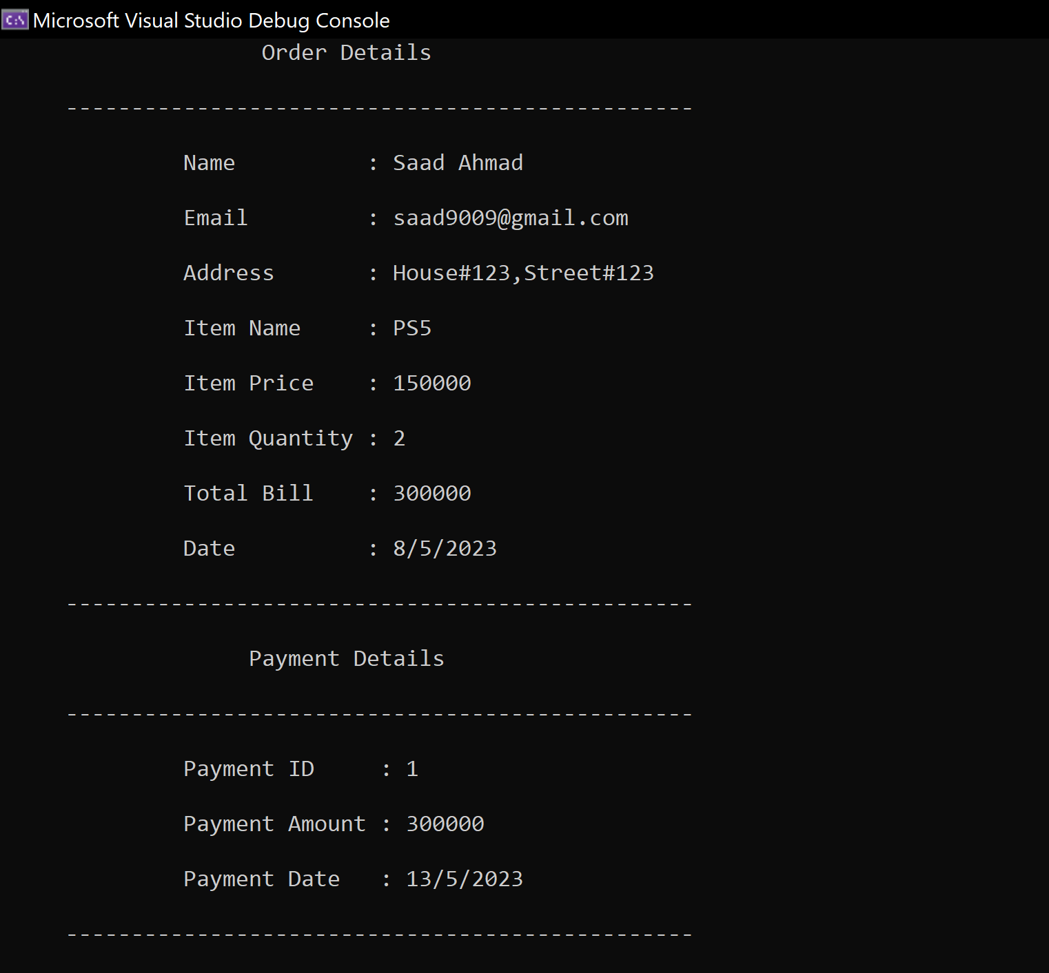

Invalid Email:

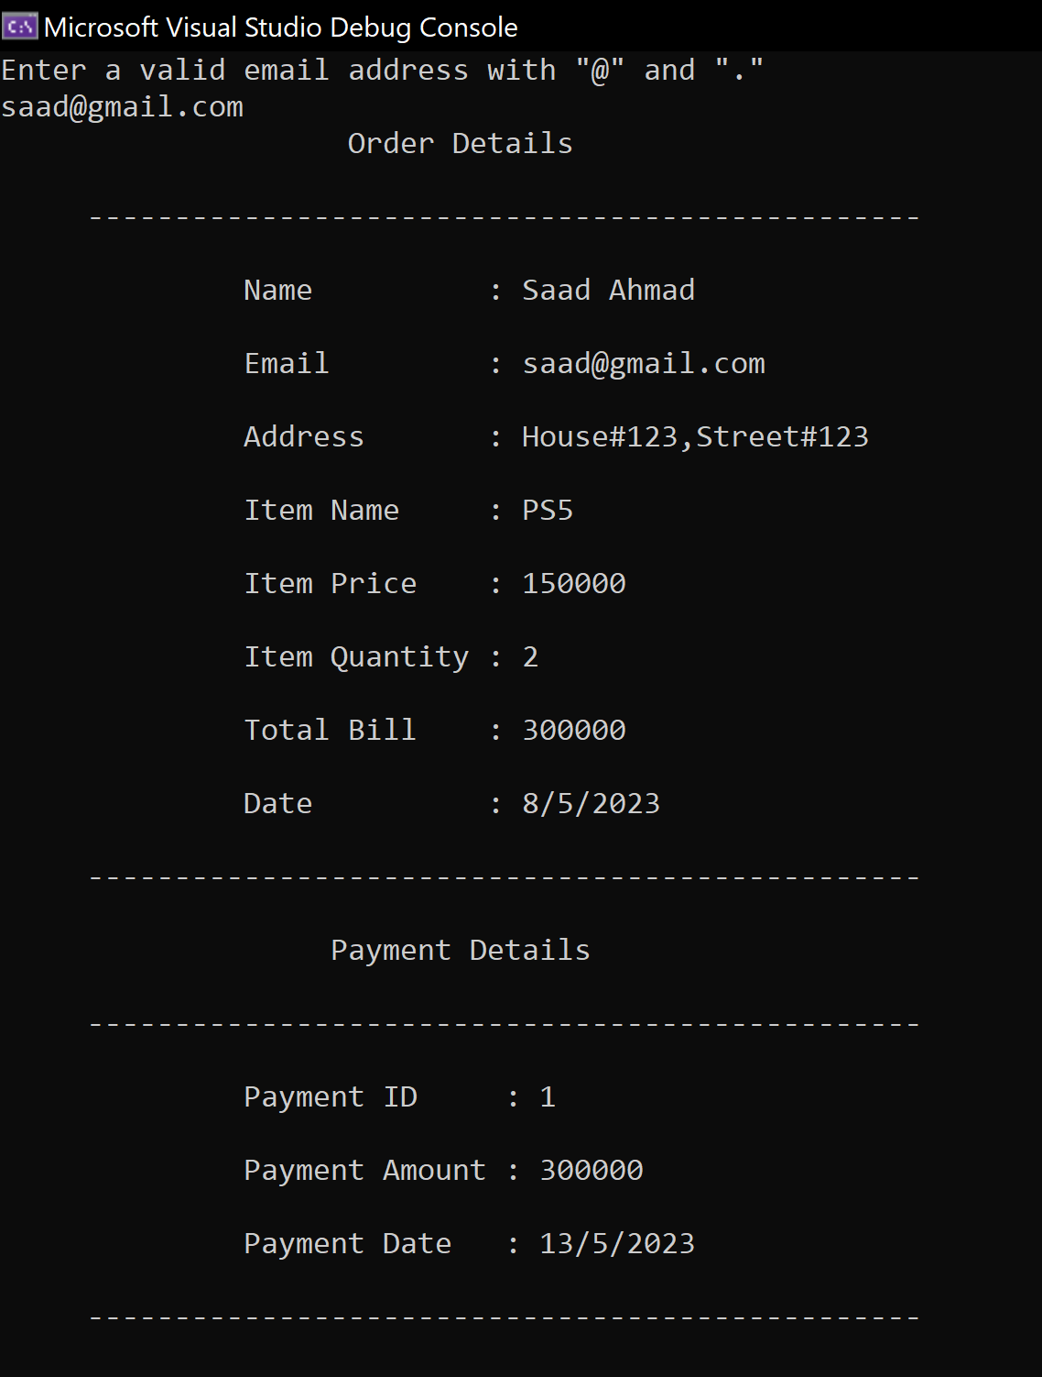

**UML Diagram:**

